MacBook Pro - Temi Debugging

# ADB Connecting to Temi

# Issue

* Both Temi and your MacBook are connected to the same iPhone hotspot, but:
  + Temi’s IP address is 172.20.10.2.
  + MacBook’s IP address is in a different range, e.g., 192.0.0.2.
* Result: Temi and the MacBook are on different subnets, so adb connect fails.

Why This Happens:

* The iPhone hotspot sometimes assigns the MacBook a different subnet, preventing direct communication between the devices.

# Debugging Steps:

1. Check Current IP Configuration (Mac)
   * In Terminal:  
     networksetup -getinfo Wi-Fi
   * Look for:
     + IP address – if it starts with 192.0.0.x, you’re on the wrong subnet for Temi.
     + Router – usually 192.0.0.1 for hotspot.
2. Check Temi’s IP Address
   * On Temi: Go to Settings → Network → Wi-Fi → (your hotspot) → Advanced (i icon).
   * Confirm it shows 172.20.10.2.
3. Make Sure Temi is Using DHCP
   * On Temi: Settings → Wi-Fi → (your hotspot) → i icon → IP Settings → DHCP.
4. Change MacBook to Same Subnet
   * On your Mac:
     + Open System Settings → Wi-Fi.
     + Click your hotspot’s Details.
     + Go to TCP/IP.
     + Change “Configure IPv4” from Using DHCP to Using DHCP with manual address.
     + Set IP Address to something in the same subnet as Temi, e.g.: 172.20.10.3 (Do not use .2 — that’s Temi’s address.)
     + Click OK, then reconnect to the hotspot.

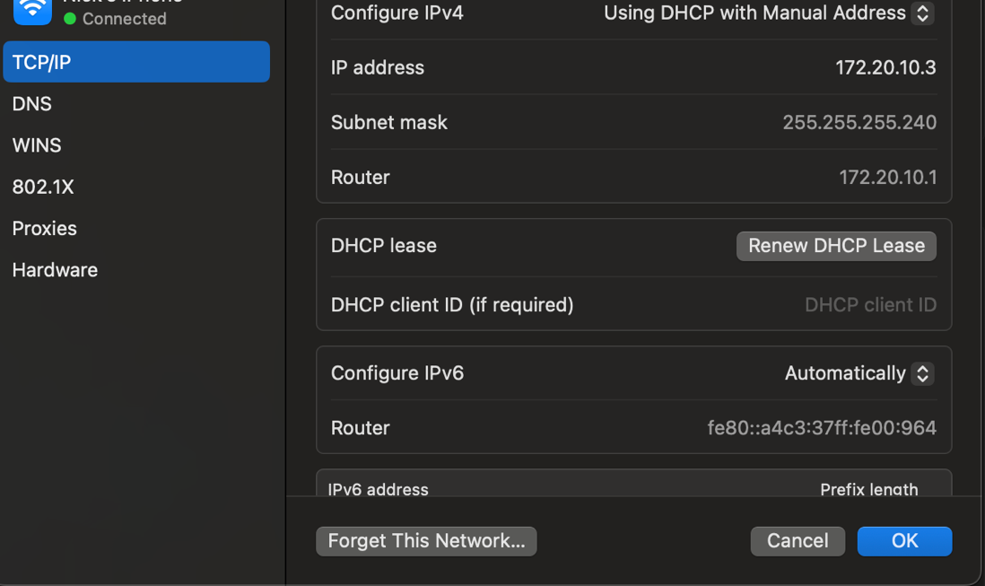

1. Test Network Visibility
   * From Mac:  
     **ping 172.20.10.2**
   * If you get replies, the devices can see each other.
2. Connect ADB
   * Ensure Temi has ADB Port Opening enabled in Developer Tools.
   * On Mac:  
     **adb connect 172.20.10.2:5555**
   * If prompted on Temi, allow USB/Wi-Fi debugging.

# Notes:

* If adb connect still fails, check:
  + Firewalls or VPNs are disabled on your Mac.
  + The hotspot is active and not in low power mode.
* If connection drops, re-open ADB Port Opening on Temi; it may time out after inactivity.

# Apple Support Debugging:

Chat – iPhone finder sidebar issue & iPhone hostpsot issues (IP address not being the same):

Num 1: 102669553219

Num 2: 102669559209

Num 3: **102669559209 (**